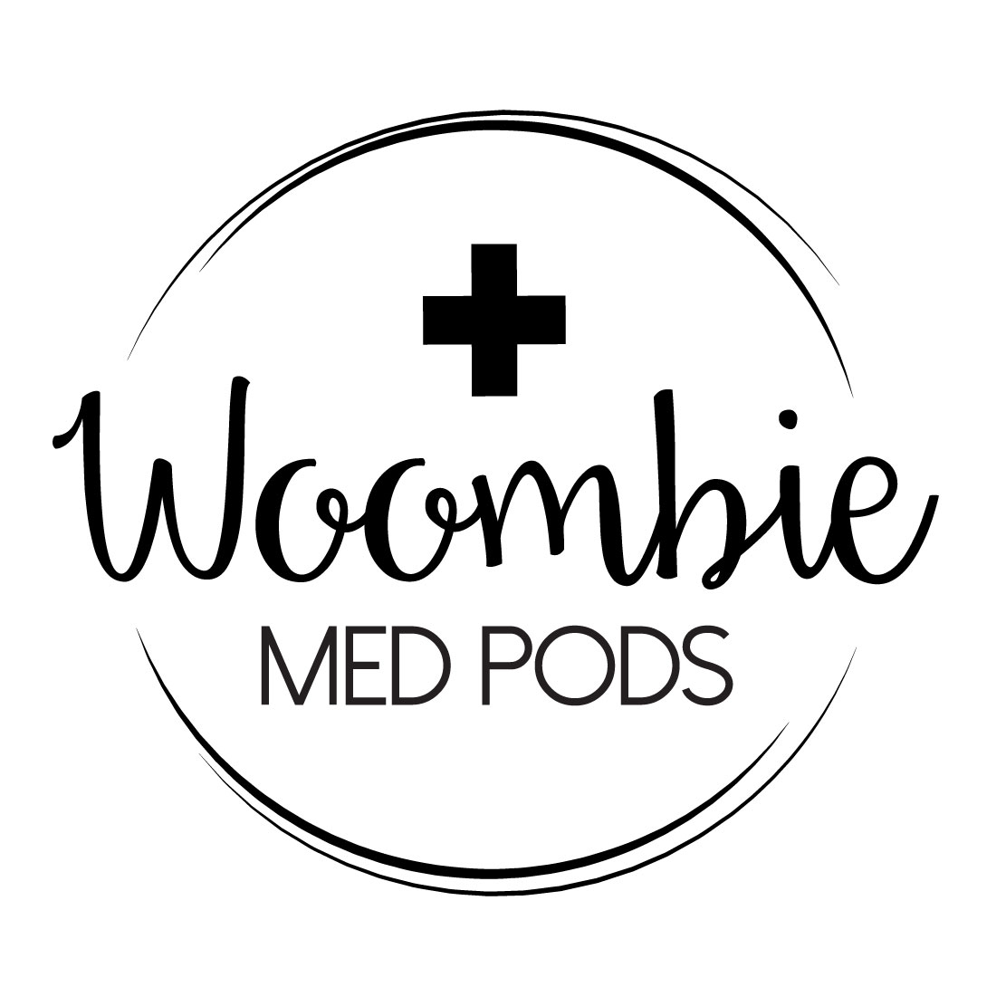

Barski Vail Designs, LLC
Chelsea Vail info@barskivaildesigns.com
Karen Barski sales@barskivaildesigns.com
1-877-MED-PODS

Frequently Asked Questions (FAQ)

Q: What is the benefit to using Woombie Med Pods over blankets?

A: Woombie Med Pods are classified as developmental care products. They provide thermoregulation, flexion, and still allow range of motion to prevent cold shoulders and hips caused by blanket swaddling.

Q: Do these meet AAP standards for safe sleep?

A: Yes, Woombie Med Pods are based on the original peanut-shaped Woombie that’s sold over a million without a single safety recall. Pods provide swaddle recommended by AAP and allow infant to sleep safely on their back with NO loose parts.

Q: Are these single or multi-patient use?

A: Woombie Med Pods can be sent home with patients for safer sleep or be used with many patients! All pods have passed OSHA standards for hospital sanitation.

Q: How are we supposed to launder them?

A: Some hospitals launder Woombie Med Pods an in-house facilities such as NICU or palliative care laundering; however, they can be stamped with hospital name and sent to commercial facilities along with other linens.

Q: Are these FDA approved?

A: Woombie Med Pods are classified as “accessories” and are used for psychosocial care. They are not curing or treating illness, but are to be used to support patient during medical treatment.

Q: What’s the luminosity on the Woombie Bili Pod?

A: The Woombie Bili Pod was tested in an SGS testing facility and showed 94% luminosity OFF a subject/patient, which is about 96-98% luminosity ON a subject. This can be used with ANY phototherapy device.

Q: What about patients with complicated tubing and leads?

A: Woombie Med Pods were designed with a double zipper to allow lines to be connected outside the top or bottom of the pod. Each pod features slits at chest and sides for other medical devices. Gastro Pod and Trach Pod were designed specifically for patients with more complicated, and perhaps permanent devices.

Q: What patient populations can benefit from Woombie Med Pods?

A: Woombie Sleepy Pod is designed to support all full-term, healthy infants on mother/baby units. The Woombie Trach Pod supports infants on cardiac, Hem/Onc, or respiratory units. Woombie Gastro Pod supports babies with colostomy bags, g-buttons, umbilical issues, or post-op gastroschisis patients. Woombie Med Pod can be used for ALL patients from micropreemie, to preemie, to pediatric patients up to 6 months age.

Q: Can Woombie Med Pods be used for procedural support?

A: YES! One of the co-creators is a Child Life Specialist who recommends using Woombie Med Pods to assist staff with invasive procedures and provide comfort to patient. Procedures like heel sticks, blood draws, dressing changes, NG tube placement, EEG, or suture placement/removal may be easier using a Woombie Med Pod.

Q: Can vital signs be checked frequently without hyperstimulation?

A: Yes. The beauty of Woombie Med Pods is the fabric is thin enough to check vital signs through without wrapping/unwrapping baby. Pulsox lead can hang through bottom zipper.

