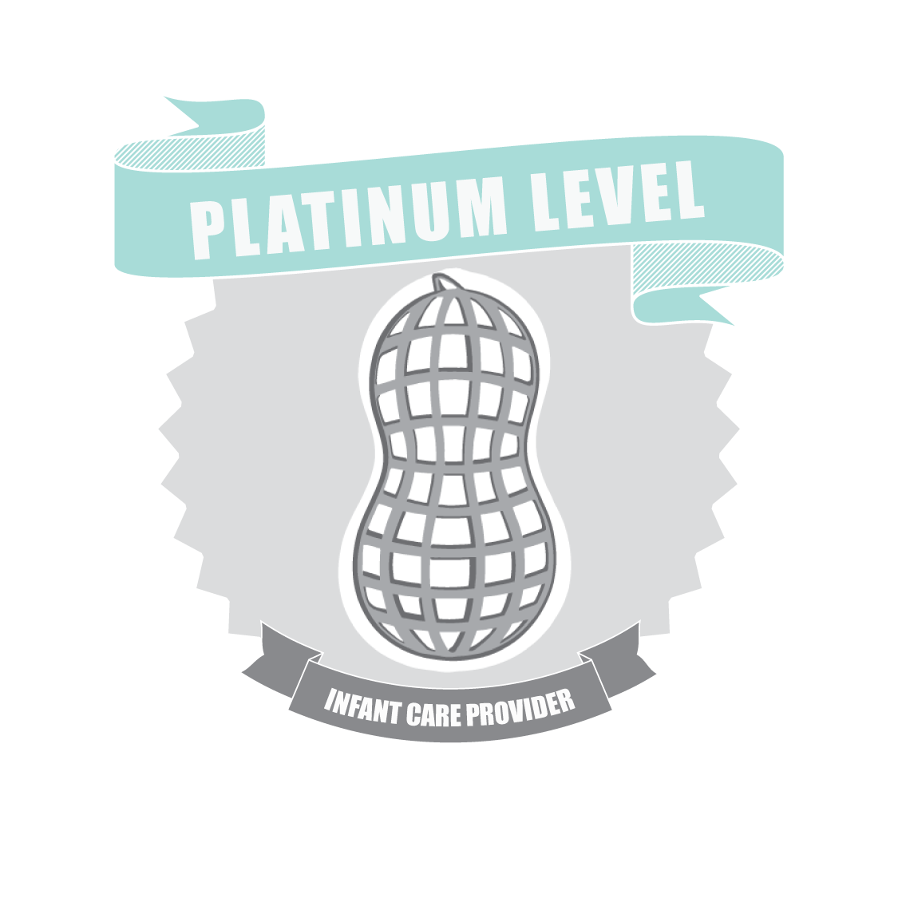
Hospital Certification Program
Become a Platinum Level Infant Care Provider

Thank you for your interest in our Hospital Certification Program. By becoming a Platinum Level Infant Care provider, you’re sending the message to the community that your healthcare system not only cares about the physical wellbeing of its tiniest patients, but you also care about their psychosocial wellbeing and are committed to their safety after discharge as well!

You can become a Platinum Level Infant Care Provider by the Woombie Med Pods team of Certified Infant Care Specialists in a few easy steps!

- Create a mission statement for infant care for your hospital, or healthcare system, that includes a commitment to developmental care and safe sleep practices hospital wide

- Staff who work with infants 0-6m must attend/view approved webinar on “Best Practices for Infant Care” and create an Infant Care Team to monitor and enforce best practices

- Provide education for parents and community on safe sleep according to AAP standards (this can be a link on your website or information included in welcome packets)

- Use Woombie Sleepy Pods or Woombie Med Pods for patients 0-3m for procedural support, safe sleep, or comfort

- Swaddle “bili” babies and NAS babies using Woombie Bili Pods during treatment

- Must not use ANY products with infants that have reported safety recalls

- Have programs in place to support low-income families

- Programs and spaces in place for breastfeeding mothers (including visitors and staff)

- Safety measures in place for labor/delivery and inpatient units, sleep, bathing, visitors, and procedural support (including circumcision)

Tell us your story…

Please tell your hospital’s story to the certification team at Woombie Med Pods and include information about safe sleep practices, current policies in place for infant care, what products are used in nurseries, NICU, and units that serve patients up to six months of age. Include information regarding parent resources, community outreach, the Child Life department, and Infant Care Teams. We’d like to know about policies and procedures regarding infant sleep, bathing, procedural support, infant play, cribs/beds utilized, car seat safety, kangaroo care, newborn care education, and developmental care products used on the units. Submit narrative and proof of meeting the above guidelines to info@barskivaildesigns.com
Tip: sending documentation such as photos, staff signatures after in services, family testimonials, links to website or written policies helps expedite certification process.

